Noemi,

I have attached the list of sites(32) where we had to deal with access issues due to “**Terms and Condition**” implementation and needs to be actioned.

The terms and condition is a newer implementation, correct me if I am wrong.

When we raise a request for a new site the these two components: List (**UserDetails**) and JavaScript (**tncauthenticated**.**js**) are injected into the team site template before they are handed over to us.

Thus, when we migrate the old site we don’t have it to begin with as a reference point.

Hence, there is nothing to compare against when users complain that there is a problem and they cannot access content.

I came across following use cases:

**Case 1: (Default implementation by Corp-IT team is to inherit permissions from the parent site → Example MBDA site)**

The inheritance for this list is also **inherited** yielding a unique situation.

There are external users who only have read only permission on the portal.

When they click on Accepting “Terms and Condition” it does not let them get into the portal because it tries to make **write** into the list where they have only **read** permissions.

[UserDetails Permissions](http://eusp.willistowerswatson.com/sites/mbda/_layouts/15/user.aspx?obj=%7BE7B5234F%2DB648%2D4576%2D8D17%2D8CDE9BAFC8FD%7D,list&List=%7BE7B5234F%2DB648%2D4576%2D8D17%2D8CDE9BAFC8FD%7D) in **MBDA site**

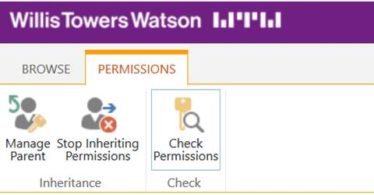

We did  not have to break the inheritance till now but if users with “ReadOnly” ever try to login we will have to break it.

**Case 2: (CRB Migration team had to  break inheritance to make it work as we could not have granted users write permission on the site → Example IVIL)**

We created a new security permission with Read, Term and Condition Access and granted permission to “Everyone” through “Style Resource Readers”

[UserDetails Permissions](http://eusp.willistowerswatson.com/sites/ivil/_layouts/15/user.aspx?obj=%7B7781F7CA%2D5B0E%2D4C62%2D8EDE%2D51882B0AA458%7D,list&List=%7B7781F7CA%2D5B0E%2D4C62%2D8EDE%2D51882B0AA458%7D) **IVIL**

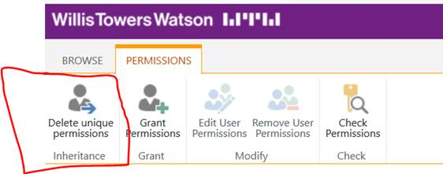

Again keeping the best security practice in mind we gave the users the minimum permissions to achieve their target.

**Case 3:** ( **We received sites where terms and condition is completely missing → Example Exposures**)

I could not find “UserDetails” list in this site collection.

<https://nasp.willistowerswatson.com/sites/Exposures/_layouts/15/viewlsts.aspx>

**Case 4: (Style Resource Reader group to have read permission, we tested with multiple users and they face access issue if it has “Limited Permissions”)**

We have made it a practice to grant “Style Resource Reader” group read permissions for all the sites.

***Recommendation***: For **Case 1** & **Case 2**, we discussed yesterday and there is an acknowledgement at your end to review it. Breaking inheritance and granting everyone “Read and write” is the only permission required in the “UserDetails” list. Given that “I accept” is a legal binding no user should be able to go into the list and be able to delete his/her entry.

For **Case 4,** I need your help as I have exhausted my options.

BALA our finding and solution

Create Permission levele-Term and condition Access-copy read permission level just add two more permissions to it,-add items, and manage personal view

Then go to User details list>>break inheritance>>give style resource reader and assign newly created permission term and condition

Site pages library and if it has unique permissions then give style resource reader –term and condition>>

Also check home page having unique permissions or what if it has then also give style resource-term and condition